**SQL-Case Study**

**Submitted By-**

**Subrat Shukla, DE Batch1**

**Creating an ‘OYO_Business’ database-**

create database OYO_Business;

use OYO_Business;

**Overview of database tables-**

select *from [dbo].[Oyo_City_CSV]

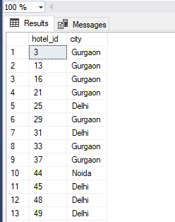

select *from [dbo].[Oyo_Sales_CSV]

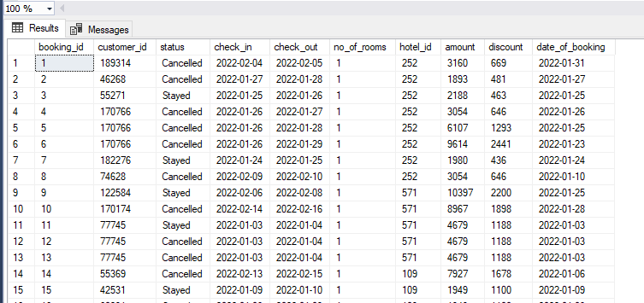

**Given Insights-**

1. Banglore , gurgaon & delhi were popular in the bookings, whereas Kolkata is less popular in bookings
2. Nature of Bookings:

• Nearly 50 % of the bookings were made on the day of check in only.  
• Nearly 85 % of the bookings were made with less than 4 days prior to the date of check in.  
• Very few no.of bookings were made in advance(i.e over a 1 month or 2 months).  
• Most of the bookings involved only a single room.  
• Nearly 80% of the bookings involved a stay of 1 night only.

1. Oyo should acquire more hotels in the cities of Pune, Kolkata & Mumbai. Because their average room rates are comparatively higher so more revenue will come.
2. The % cancellation Rate is high on all 9 cities except pune , so Oyo should focus on finding reasons about cancellation.

**SQL Queries to find-**

**1. Average Room Rates of Different Cities**

WITH CityAverage AS (

SELECT

oc.city,

AVG(os.amount / NULLIF(os.no_of_rooms, 0)) AS average_room_rate

FROM Oyo_Sales_CSV os

JOIN Oyo_City_CSV oc ON os.hotel_id = oc.hotel_id

WHERE os.status != 'Cancelled'

GROUP BY oc.city

)

SELECT * FROM CityAverage;

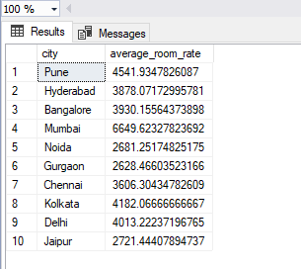

**2. Number of Bookings in Different Cities for January, February, and March**

SELECT

oc.city,

MONTH(os.date_of_booking) AS month,

COUNT(os.booking_id) AS booking_count

FROM Oyo_Sales_CSV os

JOIN Oyo_City_CSV oc ON os.hotel_id = oc.hotel_id

WHERE MONTH(os.date_of_booking) IN (1, 2, 3)

GROUP BY oc.city, MONTH(os.date_of_booking)

ORDER BY oc.city, month;

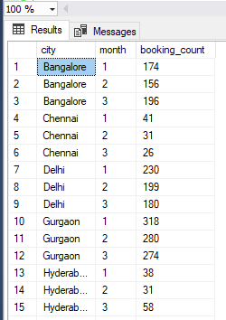 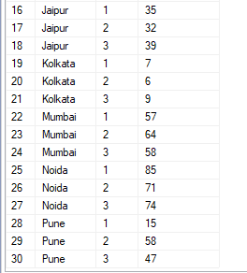

**3. Frequency of Early Bookings Prior to Check-in**

SELECT

CASE

WHEN DATEDIFF(DAY, os.date_of_booking, os.check_in) = 0 THEN 'Same Day'

WHEN DATEDIFF(DAY, os.date_of_booking, os.check_in) <= 3 THEN 'Within 3 Days'

WHEN DATEDIFF(DAY, os.date_of_booking, os.check_in) BETWEEN 4 AND 30 THEN 'Within a Month'

WHEN DATEDIFF(DAY, os.date_of_booking, os.check_in) > 30 THEN 'Over a Month'

END AS booking_timeframe,

COUNT(os.booking_id) AS booking_frequency

FROM Oyo_Sales_CSV os

GROUP BY

CASE

WHEN DATEDIFF(DAY, os.date_of_booking, os.check_in) = 0 THEN 'Same Day'

WHEN DATEDIFF(DAY, os.date_of_booking, os.check_in) <= 3 THEN 'Within 3 Days'

WHEN DATEDIFF(DAY, os.date_of_booking, os.check_in) BETWEEN 4 AND 30 THEN 'Within a Month'

WHEN DATEDIFF(DAY, os.date_of_booking, os.check_in) > 30 THEN 'Over a Month'

END

ORDER BY booking_frequency DESC;

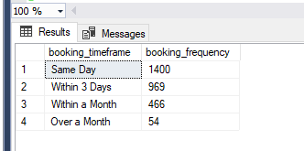

**4. Frequency of Bookings Based on Number of Rooms**

SELECT

os.no_of_rooms,

COUNT(os.booking_id) AS booking_frequency

FROM Oyo_Sales_CSV os

GROUP BY os.no_of_rooms

ORDER BY booking_frequency DESC;

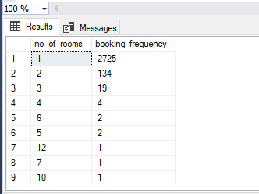

**5. New Customers in January**

Assuming that a "new customer" is identified by a customer ID with no previous bookings before January.

WITH JanuaryBookings AS (

SELECT customer_id, MIN(date_of_booking) AS first_booking_date

FROM Oyo_Sales_CSV

GROUP BY customer_id

)

SELECT COUNT(customer_id) AS new_customers

FROM JanuaryBookings

WHERE MONTH(first_booking_date) = 1;

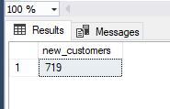

**6. Net Revenue to Company (Excluding Cancelled Bookings)**

SELECT

SUM(os.amount - os.discount) AS net_revenue

FROM Oyo_Sales_CSV os

WHERE os.status != 'Cancelled';

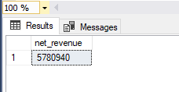

**7. Gross Revenue to Company (Including All Bookings)**

SELECT

SUM(os.amount - os.discount) AS gross_revenue

FROM Oyo_Sales_CSV os;

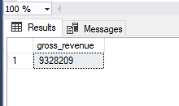

**8. Average Room Rates of Different Cities (Repeated for Clarity)**

WITH CityAverage AS (

SELECT

oc.city,

AVG(os.amount / NULLIF(os.no_of_rooms, 0)) AS average_room_rate

FROM Oyo_Sales_CSV os

JOIN Oyo_City_CSV oc ON os.hotel_id = oc.hotel_id

WHERE os.status != 'Cancelled'

GROUP BY oc.city

)

SELECT * FROM CityAverage;

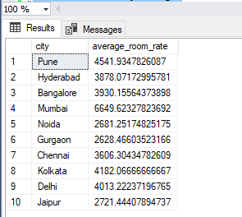

**\*\*Additional 5 self-written queries \*\***

**1. Find the Percentage of Cancellations for Each City**

This query calculates the cancellation rate for each city by dividing the number of cancelled bookings by the total bookings in that city.

SELECT

oc.city,

COUNT(CASE WHEN os.status = 'Cancelled' THEN 1 END) * 100.0 / COUNT(*)

AS cancellation_rate_percentage

FROM Oyo_Sales_CSV os

JOIN Oyo_City_CSV oc ON os.hotel_id = oc.hotel_id

GROUP BY oc.city

ORDER BY cancellation_rate_percentage DESC;

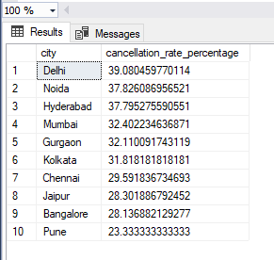

**2. List All Hotels in Cities with High Average Booking Amount (Above a Certain Threshold)**

This query lists hotel IDs in cities where the average booking amount exceeds a specified threshold (e.g., 15000).

SELECT

oc.city,

os.hotel_id,

AVG(os.amount) AS average_booking_amount

FROM Oyo_Sales_CSV os

JOIN Oyo_City_CSV oc ON os.hotel_id = oc.hotel_id

GROUP BY oc.city, os.hotel_id

HAVING AVG(os.amount) > 15000

ORDER BY average_booking_amount DESC;

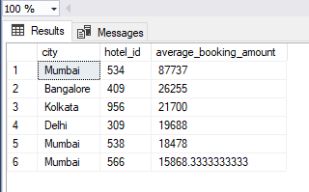

**3. Count of Bookings by Month for a Specific City (e.g., 'Delhi')**

SELECT

DATENAME(MONTH, os.date_of_booking) AS booking_month,

COUNT(os.booking_id) AS booking_count

FROM Oyo_Sales_CSV os

JOIN Oyo_City_CSV oc ON os.hotel_id = oc.hotel_id

WHERE oc.city = 'Delhi'

GROUP BY DATENAME(MONTH, os.date_of_booking), MONTH(os.date_of_booking)

ORDER BY MONTH(os.date_of_booking);

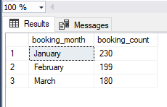

**4. Average Length of Stay for Each City**

This query calculates the average stay duration (in days) for each city by using the DATEDIFF function on the check_in and check_out dates.

SELECT

oc.city,

AVG(DATEDIFF(DAY, os.check_in, os.check_out)) AS avg_stay_length

FROM Oyo_Sales_CSV os

JOIN Oyo_City_CSV oc ON os.hotel_id = oc.hotel_id

WHERE os.status != 'Cancelled'

GROUP BY oc.city

ORDER BY avg_stay_length DESC;

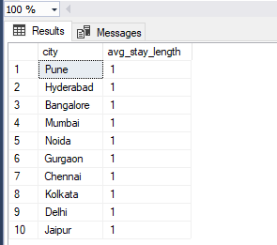

**5. Total Revenue and Average Discount Given for Each Month**

This query calculates the total revenue and average discount given per month across all bookings (excluding cancelled bookings).

SELECT

DATENAME(MONTH, os.date_of_booking) AS booking_month,

SUM(os.amount - os.discount) AS total_revenue,

AVG(os.discount) AS average_discount

FROM Oyo_Sales_CSV os

WHERE os.status != 'Cancelled'

GROUP BY DATENAME(MONTH, os.date_of_booking), MONTH(os.date_of_booking)

ORDER BY MONTH(os.date_of_booking);

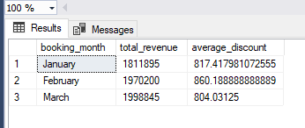

**-Thank You!**